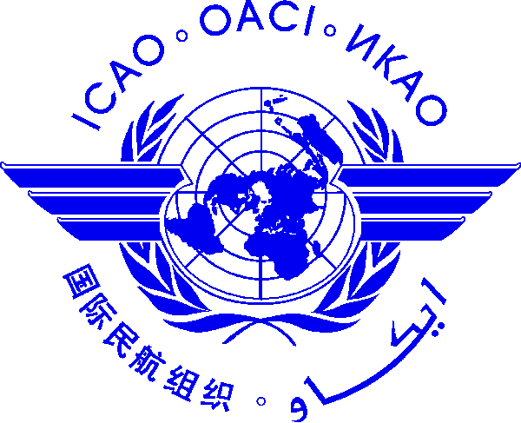 | International Civil Aviation Organization  ICAO AERODROME COURSE/WORKSHOP ON AERONAUTICAL STUDIES (SAFETY RISK ASSESSMENT)  7 July to 11 July 2014, Bangkok, Thailand

Nomination Form [please type or print]

State/ Organization
Name | Title |  | Family name (capitals) |  |  | First name |  |  | Middle initial
 | Mr/Dr/Ms.
Status |  | Principle Delegate |  |  | Delegate |  |  | Advisor
Official Position
Mailing Address
Telephone (office)
Fax
e-mail (1)
e-mail (2)
Hotel in Bangkok

Note 1: Participants are expected to make their own hotel/visa arrangements.
Note 2: All meeting material will be provided in soft copy (electronic) to participants.

Date ..........................……….... Signature ………….....………...
After completing, please send to: ICAO Regional Office for Asia and Pacific, by Fax: 66 (2) 537 8199 or E-mail: APAC@icao.int

